**GIT setup**

*These steps have to be followed to set up git on your computer. They will help connect your local to your online GitHub account.*

To start, log on to github.com and create an account if you haven’t already. The next steps will help connect your GitHub to your local.

STEPS:

1. Go to this (<https://git-scm.com/downloads>) link and download the latest version of git based on the OS you have. Once installed, select Launch the Git Bash, then click on finish. The Git Bash is now launched.
2. When you look up “Git Bash” in your search bar, an app will show up. On opening it should look similar to this:

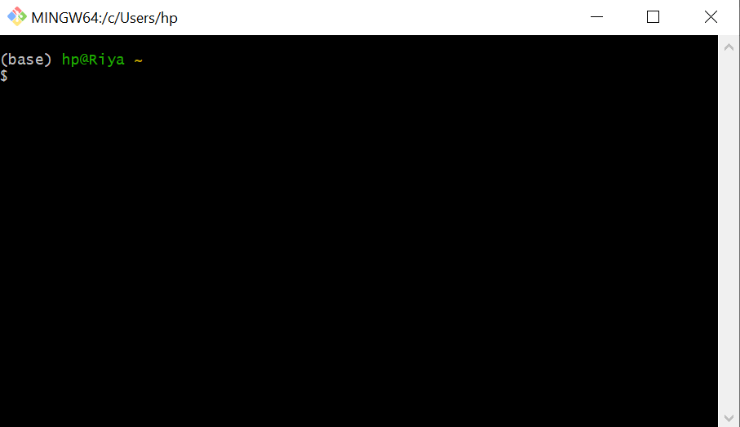

1. Type the command “git –version”. If you get an output showing the version of your git, then you are on the right track.

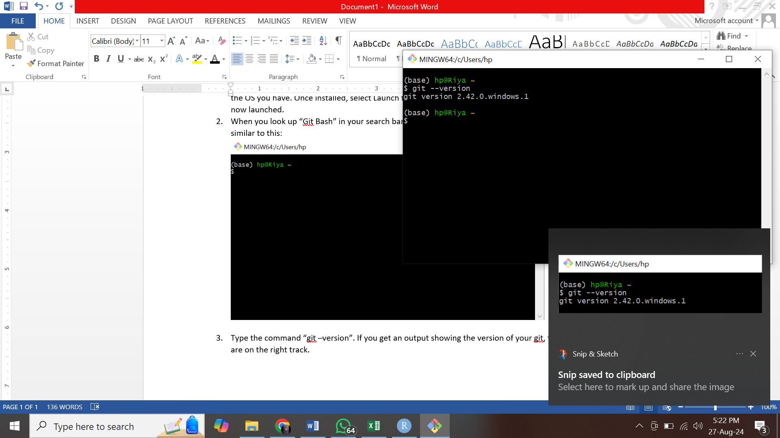

1. Link your local bash to github.com by typing the command: git config –global user.name “your_github_username”

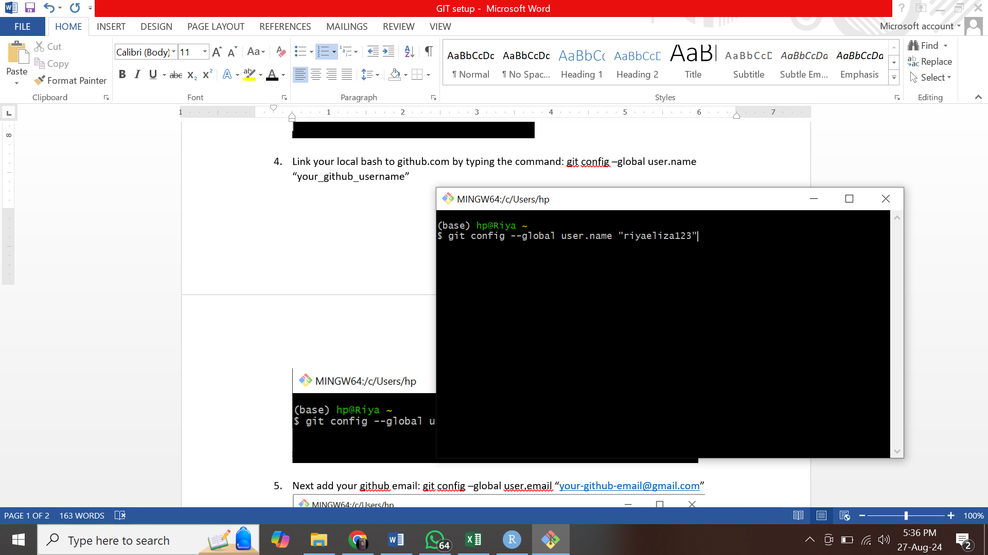

1. Next add your GitHub email: git config –global user.email “[your-github-email@gmail.com](mailto:your-github-email@gmail.com)”

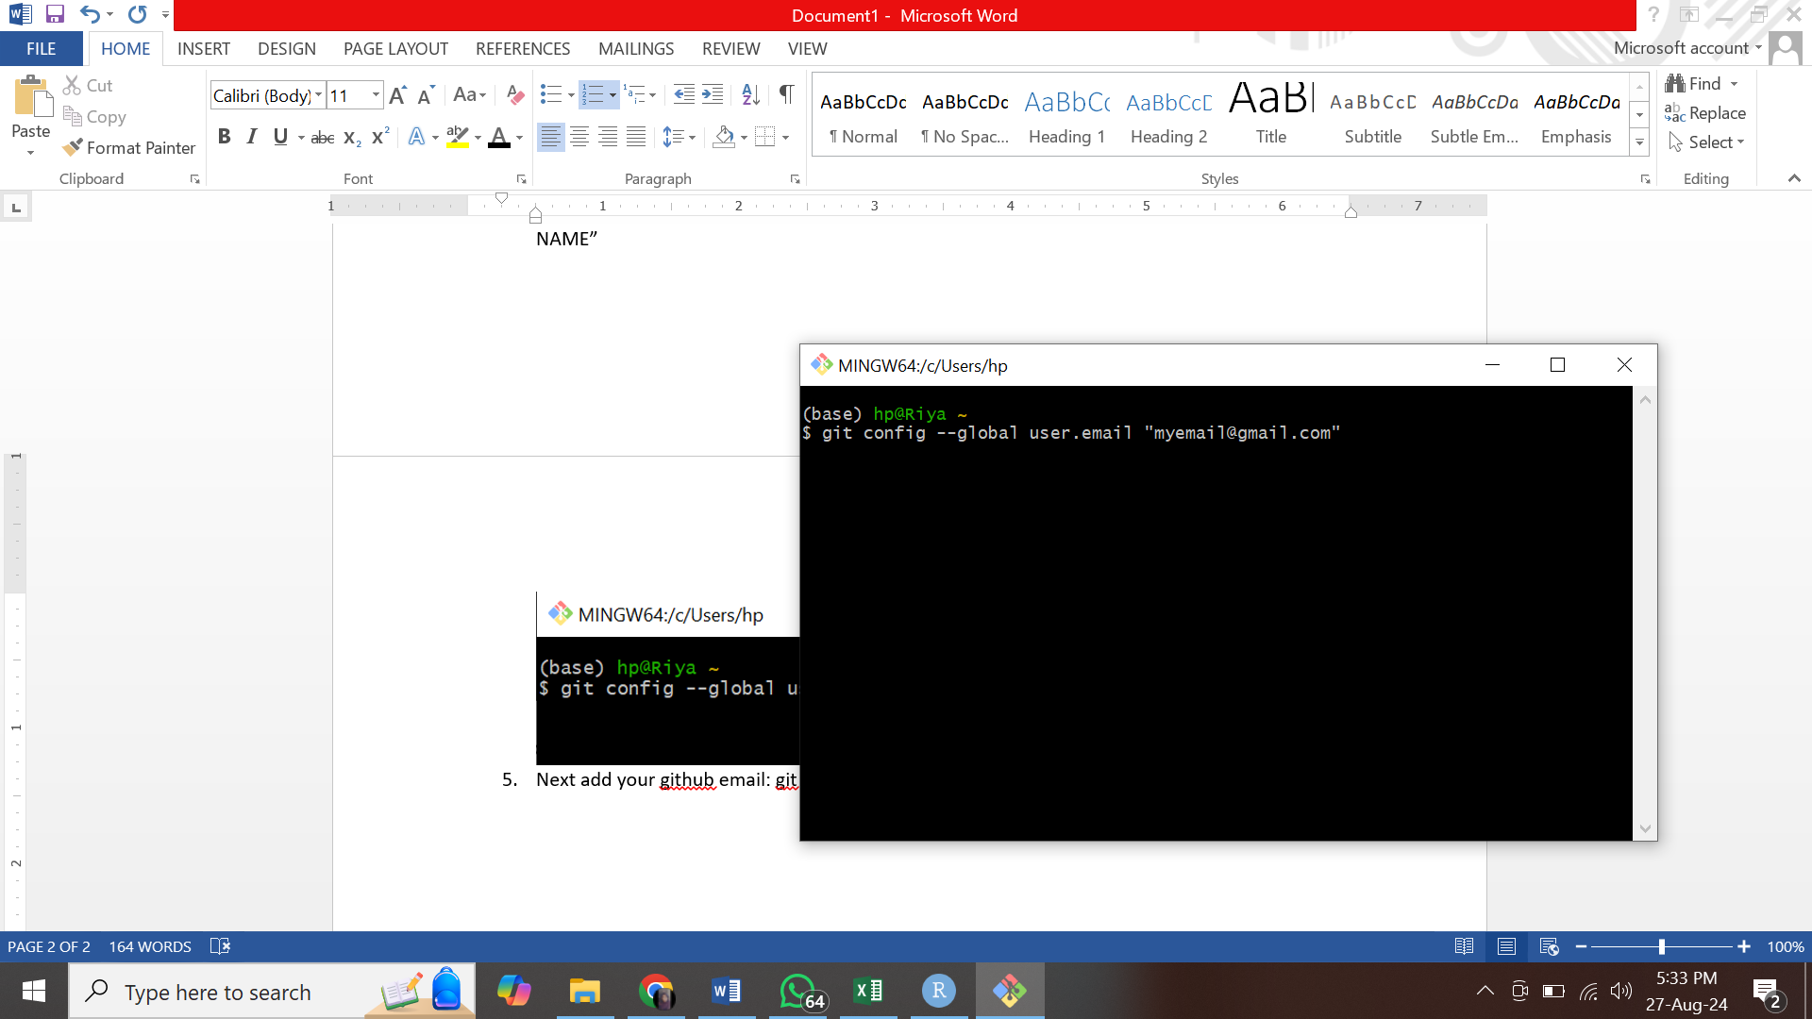

1. Setup complete!